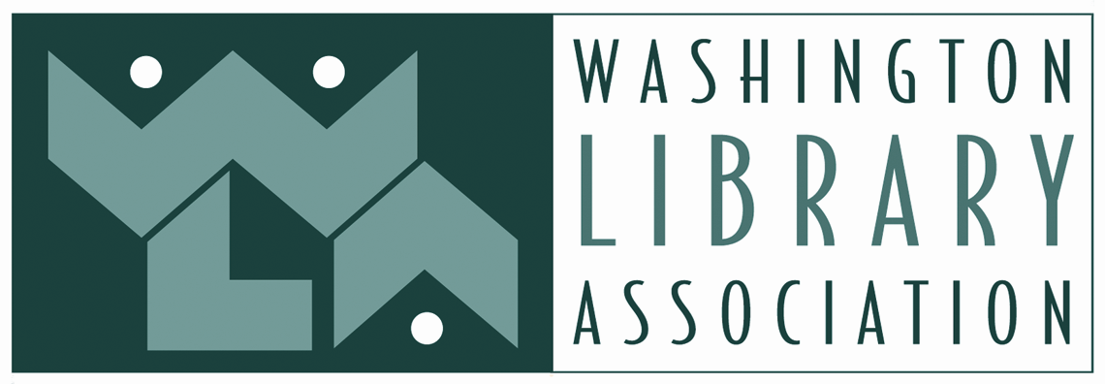
2022-2023 WLA SCHOLARSHIP APPLICATION
https://www.wla.org/wla-scholarships

PART I
Name _____________________________________________________________________________
Mailing address _____________________________________________________________________
Email _____________________________________________________________________________
Telephone number __________________________________________________________________
Best time of day to call: ☐ Mornings ☐ Afternoons ☐ Evenings ☐ Other _____________
Name of university, program, or college (if applicable) _______________________________________
Expected date of graduation _______________________
Which WLA Scholarship are you applying for? You must be a WLA member. Student membership rates are $20 per year and professional memberships are offered on a sliding scale based on income.
☐ Maryan E. Reynolds scholarship - for applicants enrolled in an ALA-accredited Master’s degree program who have completed at least one semester or quarter
☐ Hahn-Ahlers Continuing Education Scholarship - for applicants working towards a degree, certificate, or graduate-level study in the Library or Education fields
☐ John Stanford Continuing Education Scholarship - for a member of the BIPOC community working towards a degree, certificate, or graduate-level study in the Library or Education fields
☐ Denny Bond Library Paraprofessional Scholarship - for a current school library paraprofessional toward participation at a local or national library-related conference, workshop, or educational event
☐ Sharon Bates Professional Growth Scholarship - for a current school library employee toward participation at a local or national library-related conference, workshop or educational event.
☐ WALE Continuing Education Scholarship - $1000 to a WALE member toward a degree, certificate, or graduate-level study in the Library or Education fields. Sponsored by WALE (Washington Library Employees, a section of WLA)
☐ WALE Library Paraprofessional Scholarship: up to $1000 to a current library paraprofessional and WALE member toward participation at a local or national library-related conference, workshop, or educational event. Sponsored by WALE (Washington Library Employees, a section of WLA)

PART II

Please provide a personal statement of no more than 500 words that addresses the following topics:
- How does your work/study support WLA’s commitment to equity, diversity, and inclusion principles?
- What efforts have you led in support of your school or community?
- What are your goals and plans for further education and/or professional development?

Please answer the following questions:
Question 1: What current or previous involvement have you had with WLA?
Question 2: Please describe your financial need for the scholarship, including information the committee needs to consider, such as grants or scholarships already received, personal responsibility for financing education or experience, etc. This information will be kept confidential.
Question 3: Should you receive a scholarship from WLA, in which of the following activities will you participate as a way to give back to the WLA community:
- Write an article for Alki: The Washington Library Association Journal
- Participate in a Q & A session for future scholarship applicants
- Participate in a WLA interest group or committee
- Volunteer at WLA’s annual conference or other event
- Other idea for participating in WLA (Please write-in)

PART III

Attach to this completed application:
☐ Your current resume

For the Maryan E. Reynolds Scholarship:
☐ Three recommendations, with at least one from a professor or advisor in your MLIS program. The recommendation form is found on the WLA Scholarship webpage.
☐ Copy of an official transcript from the MLIS program you are attending, showing work completed during your last semester or quarter.

For Stanford scholarship:
☐ Three recommendations, with at least one from a professor or advisor in your MLIS program. The recommendation form is found on the WLA Scholarship webpage.

For Hahn-Ahlers Scholarship:
☐ Three recommendations, with at least one from a professor or advisor in your MLIS program. The recommendation form is found on the WLA Scholarship webpage.
All other scholarships:
☐ Two letters of recommendation, with at least one from someone who knows your work, such as a supervisor, advisor, teacher or professor. The recommendation form is found on the WLA Scholarship webpage.

SUBMISSION OF APPLICATION
Mail to:
Washington Library Association
Attn: Scholarships
PO Box 33808
Seattle, WA 98133

OR email application and documentation to:
info@wla.org

The application and ALL materials must be postmarked by Friday, July 8, 2022. Incomplete applications will not be eligible for consideration. You will be contacted within one week of submission to confirm receipt. Please print and keep a copy of this application for your files.
Recipients of scholarships will be notified by Wednesday, August 31, 2022.

