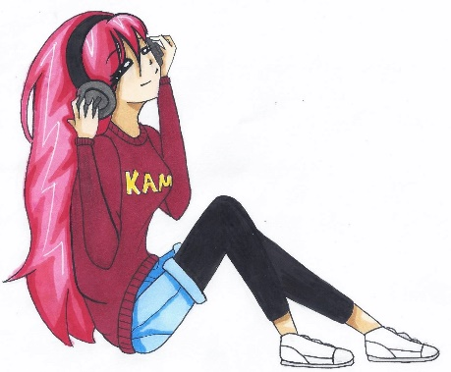
Gretchen Oates
Library Media Specialist, Kamiakin Middle School
goates@lwsd.org
booksandwoofs.weebly.com

Manga in the Middle & High School Library

Graphic Novels vs. Manga
Graphic Novels | Manga
- Read left to right  - Usually in color  - Contain more text  - Broken into square panels  - Variety of styles, but most look more realistic  - Typically written in English; often are adaptations of a fictional novel | - Read right to left  - Usually black and white  - Emotions typically portrayed in the art  - Fluid panel layout  - Variety of styles, but many accentuate features such as large eyes  - Typically Japanese authors & artists translated into English

Common Vocabulary
- Chibi: huge heads, short bodies, childlike: used for comedic purposes. Is also an art style.
- Shonen: targets boys 10-20 years old. Focuses on friendship, effort, victory. Characters train hard to defeat the enemy. Focus on action, not emotions.
- Shojo: targets girls from 10-20. Emphasizes emotions and relationships. Whole page is the story because everything has meaning.
- Cosplay: costume play. Dressing up as favorite manga, anime, video game, pop culture character.
- Manga: Japanese print comics.
- Anime: Japanese animated film.
- Fan fiction/fan fic: written by fans for fans. Usually on the internet.
- Convention/con: gathering to celebrate manga & anime, usually involves discussion panels, merchandise, and cosplay.
- Otaku: anime and manga fans (Can have negative connotations in Japan, but is widely used in U.S. as a positive association).
- Sakura Con: Annual Anime/Manga convention in Seattle presented by the Asia Northwest Cultural Education Association. www.sakuracon.org

