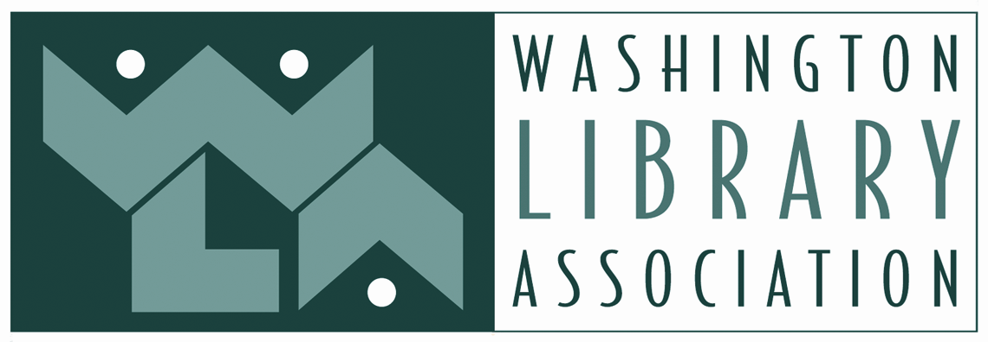
2020-21 WLA SCHOLARSHIP APPLICATION
https://www.wla.org/wla-scholarships
PART I
Name _____________________________________________________________________________
Mailing address _____________________________________________________________________
Email _____________________________________________________________________________
Telephone number __________________________________________________________________
Best time of day to call: ☐ Mornings ☐ Afternoons ☐ Evenings ☐ Other _____________
Name of university, program, or college (if applicable) _______________________________________
Expected date of graduation _______________________
Which WLA Scholarship are you applying for? (must be a WLA member)
☐ Maryan E. Reynolds scholarship - for applicants enrolled in an ALA-accredited Masters degree program who have completed at least one semester or quarter
☐ Hahn-Ahlers Continuing Education Scholarship - for applicants working towards a degree, certificate, or graduate-level study in the Library or Education fields
☐ John Stanford Continuing Education Scholarship - for applicants of color working towards a degree, certificate, or graduate-level study in the Library or Education fields
☐ Denny Bond Library Paraprofessional Scholarship - for a current school library paraprofessional toward participation at a local or national library-related conference, workshop, or educational event
☐ Sharon Bates Professional Growth Scholarship - for a current school library employee toward participation at a local or national library-related conference, workshop or educational event.
PART II
Please answer the questions below on this page or attach a separate sheet:
Question 1: WLA is a dynamic, inclusive, and diverse community that encourages engagement and equity. How does your application support these aspects of WLA’s vision?
Question 2: What are your goals and plans for further education and/or professional development? How do you expect the experience funded by this award to contribute to the Washington library community?
Question 3: Please share examples of your leadership skills or community, civic, or volunteer experiences. Please include a brief description and dates of service.
Question 4: What current or previous involvement have you had with WLA? What is your plan for participating in WLA in the year in which a scholarship might be awarded?
Question 5: Please describe your financial need for the scholarship, including information the committee needs to consider, such as grants or scholarships already received, personal responsibility for financing education or experience, etc.
Question 6: How do you plan to share the outcome of your learning with WLA and its membership?

PART III
Attach to this completed application:

For the Maryan E. Reynolds Scholarship only:
☐ Your current resume
☐ Three recommendations, with at least one from a professor or advisor in your MLIS program. The recommendation form is found on the WLA Scholarship webpage.
☐ Copy of an official transcript from the MLIS program you are attending, showing work completed during your last semester or quarter.

All other scholarships:
☐ Your current resume
☐ Three letters of recommendation, with at least one from someone who knows your work, such as a supervisor, advisor, teacher or professor. The recommendation form is found on the WLA Scholarship webpage.

SUBMISSION OF APPLICATION
Mail to:
Washington Library Association
Attn: Scholarships
PO Box 33808
Seattle, WA 98133

OR email application and documentation to:
info@wla.org

The application and ALL materials must be postmarked by May 6, 2020. Incomplete applications will not be eligible for consideration. Recipients of scholarships will be notified by June 3, 2020.
You will be contacted within one week of submission to confirm receipt. Please print and keep a copy of this application for your files.

